December Week 1
Thursday  19th December | Friday  20th December
Excursion | In Centre |  | CLOSED |  | CLOSED | CLOSED
Luna Park    Step into a world of nostalgia and excitement. Located by the water, this iconic amusement park offers a mix of thrilling rides, carnival games, and classic fun for all ages. Whether you're screaming your way through a roller coaster or enjoying the view from the Ferris wheel, Luna Park is the perfect spot for a day of light-hearted adventure and memorable moments. | Christmas at OOSH    Christmas at OOSH will be a festive celebration filled with joy and creativity! Crafting beautiful ornaments, decorating cookies, and made cheerful holiday cards. Laughter echoes as everyone joins in fun games and activities, spreading holiday cheer. It will be a day full of warmth, friendship, and the true spirit of Christmas!  Lunch Provided – Christmas lunch  3PM CLOSE |  | OOSH CLOSED  23rd December – 5th of January |  | OOSH CLOSED  23rd December – 5th of January | OOSH CLOSED  23rd December – 5th of January
Link to My Time, Our Place | Link to My Time, Our Place
1.3 Children and young people develop knowledgeable, confident self-identities and a positive sense of self.  4.4 Children and young people resource their own learning through connecting with people place and technologies. | 3.1 Children and young people become strong in their social, emotional and mental wellbeing.  1.4 Children and young people learn to interact in relation to others with care, empathy and respect.
January Week 1
Monday  6th January | Tuesday  7th January |  | Wednesday  8th January |  | Thursday  9th January | Friday  10th January
Excursion | Incursion |  | In Centre |  | Incursion | Excursion
TruNinja  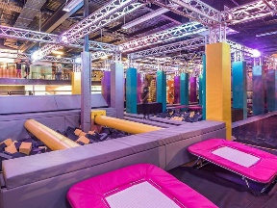  Today at TruNinja we plan to tackle various challenges, from climbing walls to balancing beams, pushing our limits and cheering each other on. We will race through obstacle courses, honing our inner ninja skills. Laughter and teamwork will fill the day, making it an unforgettable experience.  Lunch provided by venue – Nuggets and Chips |  | Splash, Splat, sponge Day    Get ready for a day filled with water activities such as slip n slides, water relays, sponge tag and much more as sparrow sport visits us for our splash and splat day. Make sure to wear old clothes or your swimmers as today is all about getting cool during the summer.  Lunch Provided – Sausage Sizzle |  | Educator Vs Children’s Day    Educator vs. Children's Day will be a fun-filled showdown that brings laughter and friendly competition! The day will kick off with engaging games where educators and children team up, testing their skills in various challenges. From trivia contests to relay races, everyone will have a blast!  Lunch Provided – Wraps | STEM day    Join us for a fun-filled Science Day where curious minds can explore the wonders of the world! Children will participate in hands-on experiments, interactive demonstrations, and exciting activities that spark their imagination. Let’s ignite curiosity and make learning unforgettable! |  | Picnic and Park Day.  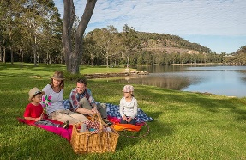  Today we make a delightful escape into nature! Join us as we spread out colorful blankets under the shade of the trees. We will play games like frisbee and tag, while also exploring the playground and water play area. Laughter will fill the air as everyone enjoys the sunshine. What a perfect day to relax, connect, and soak up the beauty of the outdoors together!
Link to My Time, Our Place |  | Link to My Time, Our Place |  | Link to My Time, Our Place | Link to My Time, Our Place |  | Link to My Time, Our Place
5.1 Children and young people interact verbally and non-verbally with others for a range of purposes.  3.2 Children and young people become strong in their physical learning and wellbeing. |  | 4.1 Children and young people develop a growth mindset and learning dispositions such as curiosity, cooperation, confidence, creativity, commitment, enthusiasm, persistence, imagination and reflexivity.  3.2 Children and young people become strong in their physical learning and wellbeing. |  | 1.2 Children and young people develop their autonomy, interdependence, resilience and sense of agency.  2.3 Children and young people become aware of fairness. | 3.3 Children and young people are aware of and develop strategies to support their own mental and physical health and personal safely.  2.4 Children and young people become socially responsible and show respect for the environment. |  | 2.3 Children and young people become aware of fairness.  3.2 Children and young people become strong in their physical learning and wellbeing.

January Week 2
Monday  13th January | Tuesday  14th January |  | Wednesday  15th January |  | Thursday  16th January | Friday  17th January
Excursion | In Centre |  | Excursion |  | Incursion | In Centre
Lollipops X Code red  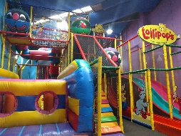  Get ready to run, jump, climb and navigate through the lollipops play area at Camellia. This day will be a day of fun and thrill as we adventure to lollipops and code red for free play and laser tag.  Lunch provided at venue – Nuggets and chips/ spring rolls and chips (V) | Yoga and Spa Day    Our yoga and spa day will be a rejuvenating retreat for the mind and body! The atmosphere is serene, filled with the gentle sounds of nature and soft music. It is a day of self-care, mindfulness, and relaxation, leaving everyone feeling revitalized and ready to take on the world!  Lunch Provided – Sausage Rolls |  | Rock Climbing  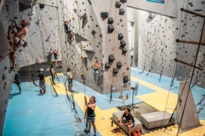  Today offers an exhilarating mix of adventure and challenge. Whether your weaving through the tunnels or scaling the walls at new heights, the activities push your limits. From novice to expert, there's a route for every skill level, making it a perfect activity our children seeking both physical and mental rewards. |  | Wheelchair basketball    Get ready to shoot some hoops at our Wheelchair Basketball Day for the children! Join for an inclusive and fun-filled experience where all children can learn the fundamentals of wheelchair basketball, regardless of their ability. With expert coaches and friendly games, participants will build teamwork skills, gain confidence, and enjoy the thrill of the game. | Minute to Win it    Children will compete in a series of fun, fast-paced challenges that test their skills, creativity, and teamwork. Participants will have a blast trying to complete challenges in just one minute, with prizes for the winners. It’s a perfect opportunity for the children to show off their talents and enjoy a day full of laughter and friendly competition. Don’t miss out on the fun!  Lunch Provided – Chicken Stir Fry
Link to My Time, Our Place | Link to My Time, Our Place |  | Link to My Time, Our Place |  | Link to My Time, Our Place | Link to My Time, Our Place
1.4 Children and young people learn to interact in relation to others with care, empathy and respect.  2.3 Children and young people become aware of fairness. | 1.3 Children and young people develop knowledgeable, confident self-identities and a positive sense of self.  3.1 Children and young people become strong in their social, emotional and mental wellbeing.  . |  | 2.1 Children and young people develop a sense of belonging to groups and communities and an understanding of their reciprocal rights and responsibilities necessary as active and informed citizens  environment.  3.2 Children and young people become strong in their physical learning and wellbeing. |  | 4.1 Children and young people develop a growth mindset and learning dispositions such as curiosity, cooperation, confidence, creativity, commitment, enthusiasm, persistence, imagination and reflexivity.  2.3 Children and young people become aware of fairness. | 4.1 Children and young people develop a growth mindset and learning dispositions such as curiosity, cooperation, confidence, creativity, commitment, enthusiasm, persistence, imagination and reflexivity.  3.2 Children and young people become strong in their physical learning and wellbeing.
January Week 3
Monday  20th January | Tuesday  21st January |  | Wednesday  22nd January |  | Thursday  23th January | Friday  24th January
Excursion | Incursion |  | Incursion |  | In Centre | Excursion
Trip to Farm    Join us for a fun-filled Farm Day adventure! Experience the charm of rural life as we explore lush fields, meet friendly farm animals, and enjoy hands-on activities. Perfect for children of all ages, this day promises fresh air, laughter, and new experiences. Don’t miss out on the chance to connect with nature and make lasting memories! |  | Meet your neighbours    Today, we take a trip to New Zealand…. Not literally but in spirit as we learn about the traditional people of the land, the Māori people. We welcome Kotahi Tourism as they host a Māori culture incursion inviting us to learn about their beautiful culture. |  | Nerf Wars  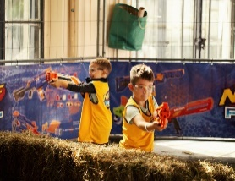  Grab your blasters, gear up with ammo, and dive into a high-energy battle where agility and quick thinking are key. Whether you're ducking behind barricades, teaming up for tactical moves, or pulling off surprise ambushes, it’s a thrilling game of fun and chaos. Nerf Wars are the perfect way to unleash your inner soldier and have a blast with friends, no matter your age. | Wheels and Tech Day    Get ready to roll at our Wheels and Tech Day for kids! Join us for an exciting day filled with biking, scootering, and tech activities. Children are welcome to bring their bikes and scooters to ride around the school, and have opportunities to play cool tech games. It's a perfect blend of outdoor fun and innovative learning!  *Do not forget Helmets and protective gear*  Lunch Provided – Sandwiches |  | 360 action park  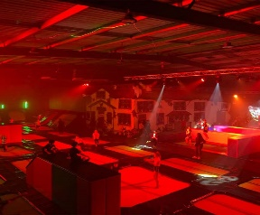  A day at the trampoline park and laser tag arena is the ultimate combo of high-flying fun and action-packed excitement! Bounce your way through an indoor playground of trampolines, testing your flips, jumps, and agility in a gravity-defying adventure. Then, shift gears and dive into a thrilling game of laser tag, where teamwork and quick reflexes come into play as you navigate darkened arenas, dodging laser beams and strategizing your next move.
Link to My Time, Our Place |  | Link to My Time, Our Place |  | Link to My Time, Our Place | Link to My Time, Our Place |  | Link to My Time, Our Place
2.4 Children and young people become socially responsible and show respect for the environment.  4.4 Children and young people resource their own learning through connecting with people place and technologies. |  | 2.1 Children and young people develop a sense of belonging to groups and communities and an understanding of their reciprocal rights and responsibilities necessary as active and informed citizens  environment.  1.1 Children and young people feel safe, secure and supported. |  | 1.2 Children and young people develop their autonomy, interdependence, resilience and sense of agency.  2.3 Children and young people become aware of fairness. | 3.2 Children and young people become strong in their physical learning and wellbeing.  2.3 Children and young people become aware of fairness. |  | 3.3 Children and young people are aware of and develop strategies to support their own mental and physical health and personal safely.  1.1 Children and young people feel safe, secure and supported.

 |  | January Week 4
Monday  27th January | Tuesday  28th January | Wednesday  29th January | Thursday  30th January | Friday  31 January
 | Incursion | Excursion | In centre | Excursion
PUBLIC HOLIDAY | Silent Disco and Slushy day    A Silent Disco and Slushy Day is the ultimate fusion of fun and refreshment! Join us for a unique, carefree vibe where you can dance and groove without disturbing the peace. Meanwhile, sip on icy, colourful slushies to keep cool and refreshed as you enjoy the beats and the buzz. It’s the perfect blend of music, movement, and chill vibes all in one unforgettable day! | Zone Bowling    Today is going to be a blast, with some friendly competition on the lanes followed by a mix of classic and new arcade games. Can’t wait to see who’ll rack up the highest score—let the games begin! | Fictional Character Day    Fictional Character Day, where everyone can unleash their creativity by dressing up as a character whose name starts with the same letter as their own! The possibilities are endless!! Celebrate your favourite characters, connect with others, and maybe even win a prize for the best costume. Let’s see how you embody your chosen character and make this a day full of fun and imagination!  Lunch Provided – Tacos | Archie Brothers  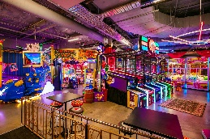  Get ready for an epic adventure at Archie Brothers Cirque Electriq! This lively arcade is packed with thrilling games, from classic pinball machines to the latest VR experiences.
 | Link to My Time, Our Place | Link to My Time, Our Place | Link to My Time, Our Place | Link to My Time, Our Place
 | - Children and young people feel safe, secure and supported.  1.4 Children and young people learn to interact in relation to others with care, empathy and respect. | 2.3 Children and young people become aware of fairness.  1.2 Children and young people develop their autonomy, interdependence, resilience and sense of agency. | 3.1 Children and young people become strong in their social, emotional and mental wellbeing.  5.1 Children and young people interact verbally and non-verbally with others for a range of purposes. | 5.1 Children and young people interact verbally and non-verbally with others for a range of purposes.  4.4 Children and young people resource their own learning through connecting with people place and technologies.

 |  | February Week 1
Monday  3rd February | Tuesday  4th February | Wednesday  5th February
Excursion | In Centre | Excursion
Inflatable world  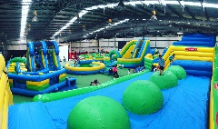  Bounce, run, jump and play as we venture to inflatable world. Today will be a day all about running around, exploring obstacles and having fun. Get ready!! | Swap Meet    Today is all about sharing. Bring in your preloved toys that are no longer being used and swap with someone else for their preloved toy.  Lunch Provided – Wraps | Rashay’s Top Ryde  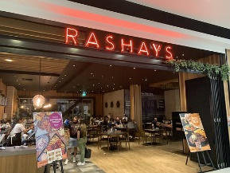  Exciting news! We're heading to Rashays for a fun-filled dining experience! Whether you're craving their famous burger or chicken nuggets, there's something for everyone. Can’t wait to dig into their delicious food and enjoy some great company!  Lunch provided – Choice of Cheeseburger or Nuggets (comes with fries) | BACK TO SCHOOL | BACK TO SCHOOL
Link to My Time, Our Place | Link to My Time, Our Place | Link to My Time, Our Place
4.1 Children and young people develop a growth mindset and learning dispositions such as curiosity, cooperation, confidence, creativity, commitment, enthusiasm, persistence, imagination and reflexivity. | 5.1 Children and young people interact verbally and non-verbally with others for a range of purposes.  1.4 Children and young people learn to interact in relation to others with care, empathy and respect. | 5.1 Children and young people interact verbally and non-verbally with others for a range of purposes.  4.4 Children and young people resource their own learning through connecting with people place and technologies.

Please note that the program is subject to change dependent upon enrolment numbers and weather conditions.
Please ensure children bring a hat, drink bottle and shoes suitable for activities each day.
Children will be supervised by staff in Centre at a minimum ratio of 1 to 15 and 1 to 10 on excursions.
Water excursions require a minimum 1 to 5 ratios. Children require rash vests, a towel and a hat to be able to swim and will be required to complete a swim test at the beginning of the day.
The anticipated number of children attending each day is approximately 0 to 30.
Completed Risk Assessments relevant to all activities are available for your information.

Bookings will open Week 7 of Term 4, November 29th, 2024, just after 6pm via the casual calendar on the Family lounge app and close on 13th of December 6pm. Please note once bookings have closed, no changes can be made to bookings and no more positions will be available.

Please not if bookings aren’t out at exactly 6pm, they should be out shortly after as our team cannot guarantee the time.

Please take note of the days you have booked as there will not be reminders and you will be charged for the day regardless of attendance.

Bookings will not be confirmed until the relevant documents have been completed and required materials have been provided including:
- Permission form
- Waiver forms
- Anaphylaxis/allergy or asthma plans
- Relevant medication
- Completed enrolments with all fields of information entered correctly.

